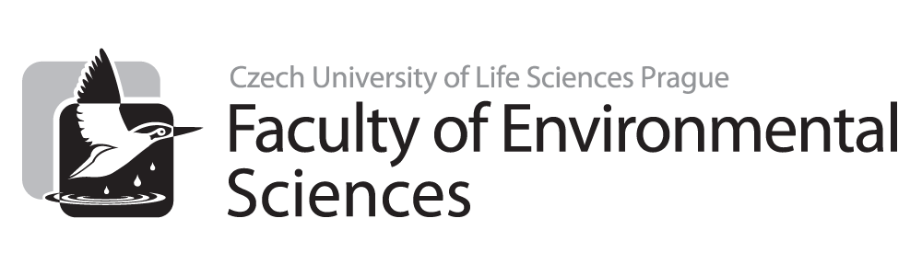

Final State Examinations for Master Programmes – Thematic Areas

2019

Nature Conservation

All thematic areas are compulsory.
CONSERVATION BIOLOGY

1. Biological diversity (BD) and threats to BD
- BD levels
- Genetic diversity (its expression and measurement)
- Species diversity (and its measurement)
- Ecosystem diversity
- Patterns of diversity (and its variation)
- The most diverse ecosystems (and the reasons for such diversity there)
- Economic values of BD (direct and indirect)
- Ethical values and arguments for preserving BD. Extinctions – past and human-caused (frequencies, range, rates and impacts, examples), estimating extinction rates, vulnerability of species to extinctions
- Threats to biodiversity – habitat fragmentation/degradation/destruction/loss, invasive alien species, overexploitation, ¨climate change, diseases, natural disasters.

2. Conservation at the population, species level and landscape
- Problems of small populations – the drivers of genetic variability (GV) loss, consequences of reduced GV, minimum viable population, effective population size, demographic variation, environmental variations and catastrophes, extinction vortices
- Using population viability analysis (PVA) in species conservation
- Island biogeography model in nature conservation (NC)
- Concept of metapopulations, sink-source theory, habitat traps
- The importance of (long-term) monitoring of species in NC
- Examples of applied research in plants and animals and its using in wildlife protection
- Species recovery programmes/actions plans and establishing new populations – translocations, repatriations, restocking, examples, conditions
- Ex situ conservation strategies – the possibilities and roles of gene banks, zoos, aquariums, botanical gardens, arboretums, examples in nature conservation
- Red lists and Red books and their roles in nature conservation. Protected areas (PAs) – the IUCN system of classification of PA, examples of PAs (comprehensive description of certain protected area – natural conditions, target species and ecosystems, problems ...), priorities (which areas should be protected)
- Designing PAs – size, shape and other relevant characteristics of PA, the problems with edge and fragmentation effect (maintenance and restoration of landscape connectivity and permeability for species)
- Practical measurements (management) in PAs (case studies)
- Ecological and other value of PAs
- Nature conservation outside protected areas – the value of unprotected areas, nature conservation in urban areas and other types of landscapes (case studies)
- Restoration ecology – ecological restoration of landscapes disturbed by different human activities (mining, agriculture, forestry..., case studies).

ECOSYSTEMS CONSERVATION AND MANAGEMENT
- Conservation at Ecosystems Level: ecosystem - definition, primary and secondary ecosystems across Europe, biomes and biogeografical regions in Europe, types of management, management plans, inventory-based management.
- Conservation and Management of Forest Ecosystems: main forest biomes in Europe, threats to forest biodiversity, species and age composition of forest ecosystems, dead wood in forest ecosystem, spatial heterogeneity of forest ecosystems, examples of endangered forest species, fragmentation and ecotonal effect, intensive and extensive forestry, sparse tree vegetation in agricultural landscape.
- Conservation and Management of Freshwater Wetlands: basic characteristic and wetlands types in Europe, threats, meaning, use and conservation of wetlands, the Ramsar Convention, eutrophication. Conservation and management of rivers and streams, fish migration. Conservation and management of fishponds, lakes and littoral vegetation. Conservation and management of peat-bogs. Examples of endangered species.
- Conservation and Management of Grasslands: basic characteristic and types of grasslands in Europe, threats, meaning, use and conservation of grasslands, methods of management, grazing as a management method, examples of endangered species.
- Conservation and Management of Heathlands, Saline and Sand Ecosystems: basic characteristic and types in Europe, threats, meaning, use and conservation, methods of management, examples of endangered species.
- Conservation and Management of Rocks Ecosystems and Quarries: basic characteristic and types, threats, value and conservation, methods of management, examples of endangered species. Conservation and management of sandstone ecosystems in the Czech Republic and Europe. Restoration of devastated stands.
- Conservation and management in Agricultural Ecosystems basic characteristic, threats, conservation value, examples of management methods, examples of endangered species, agro-environmental programmes.

ANIMALS AND PLANTS ECOLOGY
1. Mutual and exclusive traits of animals, world’s biodiversity of animals.
2. Adaptations, exaptations, genotype, heredity and heritability, mutations, phenotypic plasticity, fitness, natural selection.
3. Genetic diversity and polymorphism, genes under selection, local adaptations, inbreeding and outbreeding, founder effect, bottleneck.
4. Life history traits, life strategies, r- and K- selection, trade-off principle.
5. Behavioral ecology, cooperation, kin selection, game theory and evolutionary stable strategies.
6. Chemical communication.
7. Asexual and sexual reproduction – costs and benefits, gonochorism and hermaphroditism, sex determination and sex reversal, sexual dimorphism.
8. Mating systems, sexual conflict, mechanisms of sexual selection, role of signals, sperm competition.
9. Reproduction strategies, hybridization and hybridogenesis, assortative mating.
10. Migration and dispersal. Navigation in animals.
11. Niche concept, habitat selection, territoriality and home range, intraspecific competition.
12. Evolutionary ecology of host-parasite interactions, pathogenicity and virulence.
13. Theory of island biogeography and metapopulation concept, effects of habitat fragmentation, habitat edges and ecological traps on animal populations, Allee effect.
14. Modularity in plant species.
15. Pollination and mating systems in plants.
16. Hybridization and polyploidization in plants.
17. Spreading in space and time.
18. Life cycles, strategies and population dynamics of plants.
19. Clonal growth.
20. Intraspecific and interspecific competition in plants.
21. Plant community structure: competition and disturbance.
22. Communities and succession.
23. Theory of island biogeography.

CONSERVATION POLICY
1. Conservation policy – definition and key approaches to it; nature conservation as a social activity, its basic instruments, approaches and targets; main nature conservation fundamental paradigms in the past and present (wilderness, nature as a heritage monument, nature´s balance, biological diversity, sustainable development, ecological/ecosystem integrity, ecosystem services);
2. Geopolitical conditions of nature conservation; global ecology v. global change ecology; biodiversity loss main drivers at the global, EU and national level; challenges and limits conservation policy;
3. National nature conservation laws, EU nature conservation legislation, multilateral agreements related to nature conservation (e.g., Convention on Biological Diversity, Convention on Migratory Species and its agreements, Ramsar Convention, CITES, World Heritage Convention, Bern Convention, European Landscape Convention; Alpine and Carpathian Conventions);
4. Funding nature management (GEF, LIFE, agri-environmental and climate change schemes, national subsidiary schemes/subvention programmes), science, research. monitoring, inventories/surveys, innovations and indicators, communication, education and public awareness;
5. International institutions, programmes and initiatives related to nature conservation and management (UN agencies and programmes and other inter-governmental bodies, e.g., OECD, IPBES); role of international and national NGOs (e.g., IUCN, WWF, Greenpeace, Conservation International, BirdLife International, Planta Europa); citizen science as a part of the post-normal science;
6. Nature conservation policy in the EU (implementation of the EU nature conservation legislation; other EU environmental laws; Common Agricultural Policy; Common Fishery Policy);
7. Nature conservation at the international level (UN Sustainable Development Goals; CBD Strategic Plan and its Aichi targets 2011-2020; pan-European and EU Biodiversity Conservation Strategy; EU Sustainable Development Strategy);
8. Economics and conservation policy – environmental v. ecological economics; ecosystem service;, integrated ecosystem assessment; natural capital and its accounting; payments for ecosystem services; green and circular economy concepts;

